**Public Petition to Postpone the Vote on IFPD Ordinance 513-01**

The Idyllwild Fire Protection District is seeking to pass a local ordinance and addendum to the California Building Code. The ordinance, if adopted will have large financial implications for Idyllwild residents seeking to remodel or add small structures on their lot, reduce affordable housing a take away business opportunities for local construction contractors. A vote to formally adopt the measure is scheduled for 3PM August 25, 2020. The proposed ordinance can be found on page 16 of the IFPD Board meeting agenda for August 25th, 2020 (<https://idyllwildfire.com/board-meeting-agenda.html>) and reads:

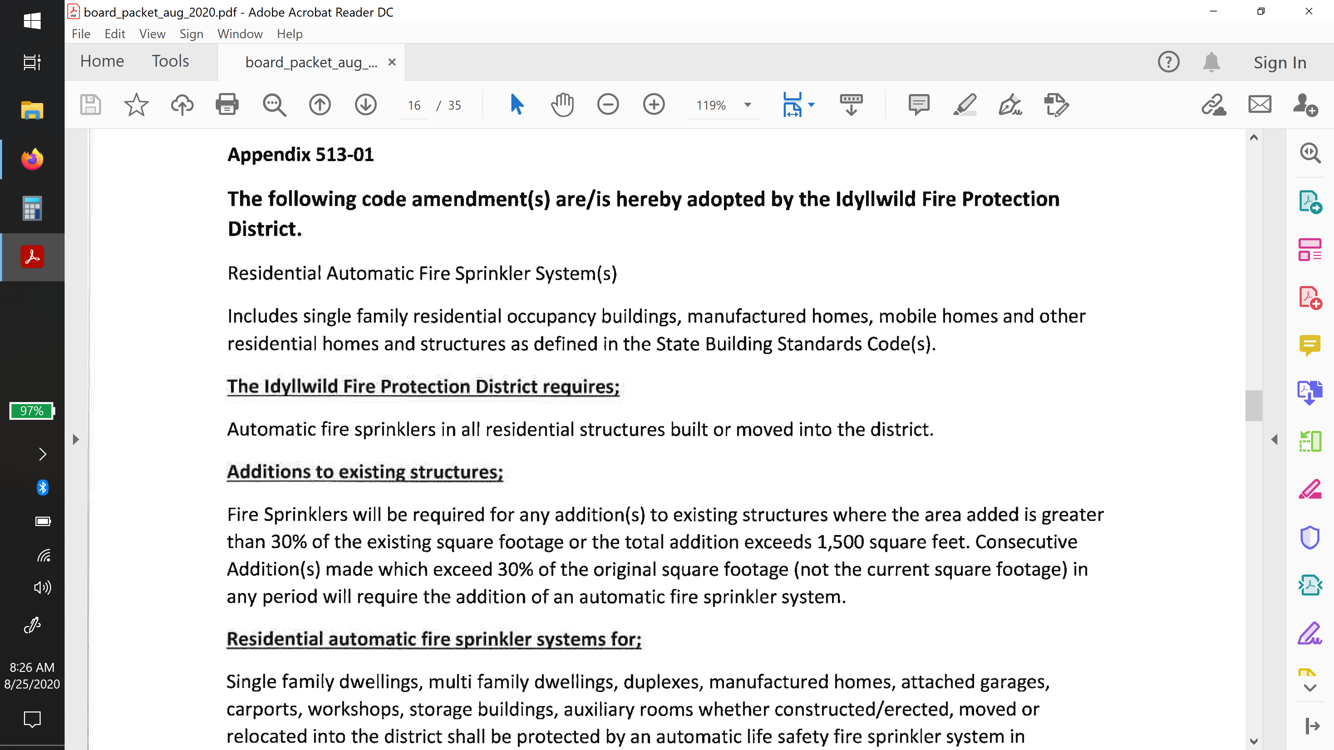

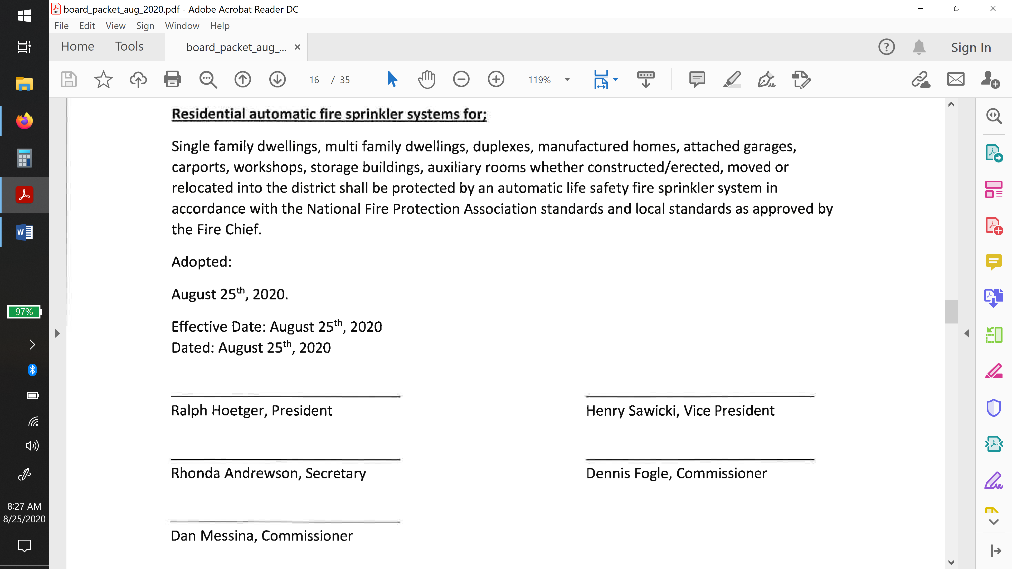

Given the implications of such a measure, the residents of Idyllwild deserve the right to have an open conversation and voice their opinion regarding the matter. If you agree, please sign this petition to table the vote on proposed IFPD appendix 513-01 until the public has had at least 30 days to communicate their position to the IFPD Board of Commissioners. If you can't sign the physical petition, reply here saying you wish your electronic signature to be added.

**Name and any other information you choose to provide (PO Box, email, phone, etc.)**

1) ____________________________________________________

2) ____________________________________________________

3) ____________________________________________________

4) ____________________________________________________

5) ____________________________________________________

6) ____________________________________________________

8) ____________________________________________________

9) ____________________________________________________

10) ____________________________________________________

11) ____________________________________________________

12) ____________________________________________________

13) ____________________________________________________

14) ____________________________________________________

15) ____________________________________________________

16) ____________________________________________________

17) ____________________________________________________

18) ____________________________________________________

19) ____________________________________________________

20) ____________________________________________________

Please add additional numbers for more lines as needed.